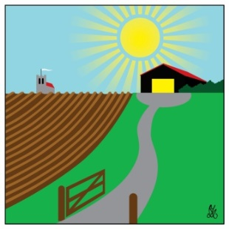
Debenham Shed
Our AGM will be held at 4pm after a normal Shed session on Friday 27 May. This will be followed by a barbecue—all welcome (except dogs, unfortunately).
We will have a stall at DebFest on Saturday 11 June, showing what we’re up to and selling some surplus tools and other items.
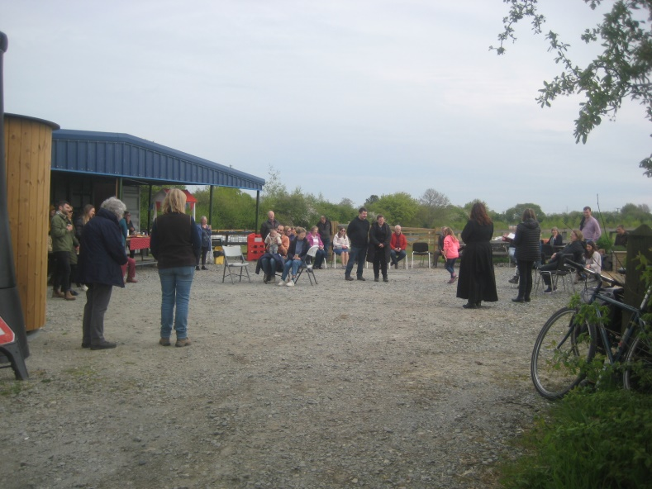
We meet on Friday afternoons from 2-5pm. Just turn up if you’d like to join in or have a look. It is hoped to run additional sessions on another weekday and possibly at weekends at some time in the future; please let us know if this would be attractive to you, and what days/times you would prefer, at chairman@debenhamshed.org.uk.
The Rogation family@church Service on Sunday 1st May, led by curate Tracey James started with refreshments at the Shed.
Debenham Shed is at 2 Fields, Low Road (IP14 6BJ). Affiliated to UK Men’s Sheds Association. Debenham Shed Officers: Les Wright 07793 470694, Bernard Rose 07538 974119, Tony Hutt 07906 614328. Visit our website at www.debenhamshed.org.uk, where you can sign up to our newsletters on the Contact page. Like our Facebook page at www.facebook.com/DebenhamShed.

