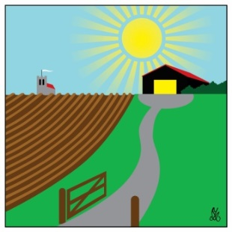
Debenham Shed
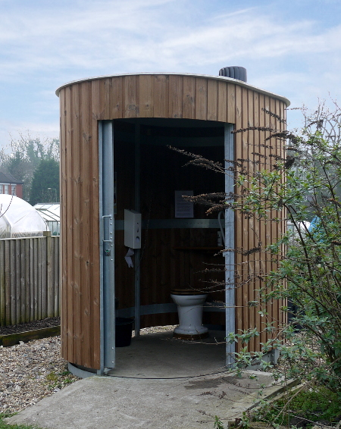Our low-maintenance, accessible, composting toilet (similar to the photo) is arriving in January and will be installed this month, thanks to further funding from the National Lottery Awards for All (and other grants already received). This also provided contributions for internet provision, security and other improvements.
If you are shopping at Stowmarket Tesco from January to March please ask for a blue token to vote for Debenham Shed in the Community Grants stand on the way out! We are bidding for funds for heating and ventilation.
We continue to meet on Friday afternoons from 2-5pm. Just turn up (no dogs please) if you’d like to join in or have a look.We will soon start some training sessions, e.g. routers and chop saws; if you are interested, let us know first.
See www.eadt.co.uk/news/east-together-debenham-shed-open-day-8191418 for an an excellent article and video about our official re-opening on 20 July.
The Debenham Shed is at 2 Fields, Low Road (IP14 6BJ). Affiliated to UK Men’s Sheds Association. Debenham Shed Officers: Les Wright 07793 470694, Bernard Rose 07538 974119, Tony Hutt 07906 614328. To receive occasional news by email contact us at debenhamshed@gmail.com. Like our Facebook page at www.facebook.com/DebenhamShed.

