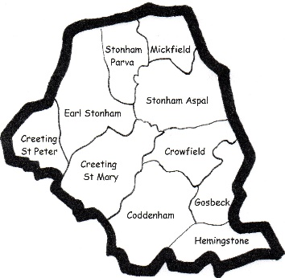
THE NORTH BOSMERE BENEFICE
Coddenham, Creeting St Mary,
Creeting St Peter, Crowfield,
Earl Stonham with Stonham Parva, Gosbeck,
Hemingstone, Stonham Aspal and Mickfield

Service of Light – Sunday 31 October

3.30pm Earl Stonham

This special Service will give you the opportunity to
remember your loved ones. The names of those who
have died will be read out during the service.

“Though I walk through the valley of the shadow of death, I will fear no evil,
for You are with me, Your rod and staff they comfort me” Psalm 23:4

This invitation comes to anyone in our Benefice who has lost a loved one recently,
or at some time in the past.

We would welcome you, and any friends or family, to this service when we remember all those whom we have loved but no longer see.
Sometimes children, or those who have not been able to attend a funeral, may appreciate a chance to remember those who have died.

This is a simple service of hymns and prayers with an opportunity to light a candle in memory of your loved one. As you arrive you will be able to add a name to be read out during the service.

Names of anyone you wish to remember will be read out and if there is someone you would like to be added please let Frankie or Helen know, their details are below.

Frankie Wicks: 01449 711222 frankie@moatfarm.online

Rev Helen Norris: 01449 761867 h.norris1@hotmail.co.uk

